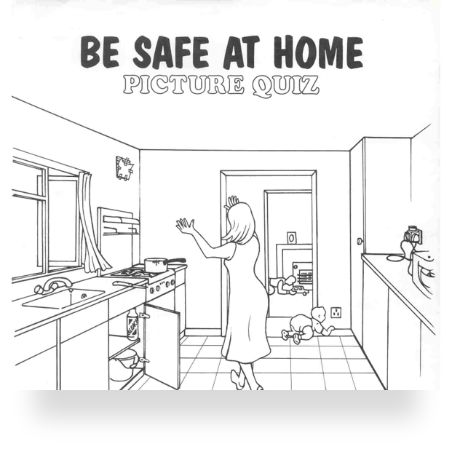

How many dangers can you spot in this situation?

